
Opening

- of Belgium’s first secured truck parking area
- of the new “healthy food” restaurant concept | 

Liège Logistics – Bierset (Grâce-Hollogne), 20 May 2010

Press conference

Speakers:
- Mr André Gehlen, managing director - VP Group
- Mr Benoit Salmin, marketing director - VP Group
- Mr Fabian Mossay, director - IDFM (Ideal Cooking)

Attended by:
- Mr Jean-Claude Bodson, purchasing director - VP Group
- Mr Bruno LECLOUX, credit and logistics director – VP Group
- Mr Jean-Pierre Robinet, Executive Manager - Miam®
- Mr Luc NELLES, project developer/architect
Contents

VP Group 3
Background
The company
Q Team, the tyre experts 4

VP Park 5
The context
VP Group’s response

Security & Convenience 6
Security: the No. 1 priority
Convenience is key 7

Miam®: a unique “healthy food” concept 9
The catering firm Ideal Cooking
The Miam® concept

Outstanding buildings 10
Architecture
Environmentally friendly 11
Great location 12
VP Group

Background

VP Pneus, formerly Verviers Pneus, has gone under the new name VP Group since 2009.
The company was founded in the early 1970s by Alain Bruyneel. After his tragic death in 1996, his partners continued to expand the business.

The company

Today, VP Group operates in 4 core businesses:
- tyres
- truck and van concessions
- service stations
- new secured truck parking

In terms of figures, VP Group has:
- 58 tyre service points, concessions and service stations
- 25 legal entities
- More than 300 full-time employees
- a turnover of more than €125 million
- 50% of its customers are from the road transport sector

VP Group’s strategic aims include the desire to provide customers with a:
- multi-service,
- multi-product and
- multi-brand offer.

The various group companies recently indicated the fact that they are part of VP Group by adding the letters VP to the company name.
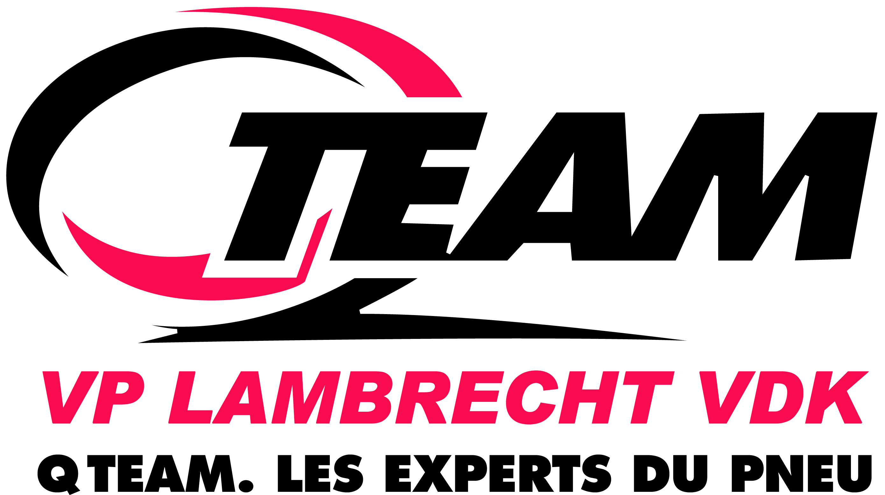
Q Team, the tyre experts

With an on-site presence via a fitting station, the “Q Team, the tyre experts” name is the best-known part of VP Group.

Q Team was founded following:
- the 2002 merger between VP Group “tyre stations” and Lambrecht and Vandeckerkhove, two other leading family groups in the sector
- the 2003 takeover of Speedy when the company went bankrupt

The company has a foothold in the 4 “tyre” customer segments:
- individuals
- hire companies
- truck (hauliers) and passenger vehicle (company cars) fleets
- resale to garage owners

Q Team’s business volume can be summarised in a few figures:
- 95 points of sale
- turnover of more than €140 million in 2009
- 450 employees
- more than 60 breakdown vehicles
- more than one million tyres sold annually
VP Park


The context

Every year, freight thefts from trucks in Europe total €8.5 billion. There are no specific figures available for Belgium, but a quick estimate throws up the figure of €350 million. Not to mention attacks on truck drivers and the resulting consequences.
Due to a lack of truck parking in Europe, truck drivers are often forced to stop at places which are not really appropriate in order to comply with legislation, resulting in a high risk of accidents.
Nor should the impact of repeated poor quality rest on drivers be underestimated.

VP Group’s response

The VP Park secured truck parking area in Bierset is the answer to all these problems for the Liège region.
The “natural” logistics vocation of the Liège region (geographic location, dense motorway network, Liège Airport, high-speed train link, autonomous port, mechanically-skilled labour, availability of land at competitive prices, etc.) led VP Group to choose the Liège Logistics site as the location of a multi-service point aimed at trucks.

In fact, this project has been selected by the European Commission in the framework of the SETPOS (Secure European Truck Parking Operational Services) project, which aims to establish a future standard in Europe for secured truck parking. VP Park is one of just 5 sites in Europe selected under this SETPOS project, and the only one in Belgium.

VP Group wanted to bring together all of its core businesses on a vast 10 hectare plot by carrying out 2 phases:
- phase 1
  - secured parking
  - service station
  - sale of tyres
  - restaurant
→ opens on 20 May 2010
- phase 2
  - construction of a building to house the 4 brands of goods vehicles
→ work starts in 2011
Security & Convenience

Security, the No. 1 priority

The true cornerstone of VP Park, security is reflected in particular by:
- 1 km of 2.5 metre high “Power Fencing”, i.e. electric fencing to prevent any intrusion
- 20 peripheral cameras, which record all movements round the clock
- a central building handling all the data
- a full lighting system in order to be able to see clearly at all times without ever disturbing drivers resting in their cabs
- extremely secure access to the guarded parking area through a double entrance for trucks coming in and out
  - each vehicle is photographed and recorded
  - not possible to leave without going back through the double entrance
  - at which point the computer compares the photos on the way out with the photos on the way in. If there is any element of doubt, the gates do not open
  - drivers who want to leave the parking area on foot must pass through a purpose-built “pedestrian” turnstile, with systematic checks
- a night-time surveillance service
- guards constantly on duty during the day

- special ADR spaces (hazardous goods) with a recuperator for products which might leak out

 maximum security for drivers
trucks
freight
Convenience is key!

Primarily aimed at target customers which it knows particularly well, with VP Park, VP Group has developed a multi-service complex to meet all the requirements of truck drivers in terms of convenience.

This goal has been achieved through quite a few features:

- the truck parking area

  - 200 spaces for truck semi-trailers and tractor semi-trailers
  - special spaces for refrigerated trucks with power hook-up

- the “station-shop-sandwich shop” complex (6 a.m. to 10 p.m. on weekdays – 8 a.m. to 8 p.m. at weekends)

  - the Total service station

    - for privately-owned vehicles: 4 multi-product pumps: diesel, super 95 and super 98 petrol and LPG
    - for trucks: 4 special diesel truck pumps
    - with satellite pump, a device which enables drivers to fill up both sides of the truck in the same operation
    - supply of AdBlue, a technology which enables Diesel trucks to reduce their emissions of nitrogen oxides
    - all international payment cards + AS24

- the shop

    - all the essentials: food and sandwiches, drinks, cigarettes, newspapers and magazines, personal care products, truck accessories, etc.
    - a Croustifrance sandwich shop with on-site cooking

- driver services, inside the station
  - WCs, showers, laundrette, etc.
  - relaxation area
  - Wi-Fi connections
- a tyre service, with the “Q Team, the tyre experts” network

  - specialising in car tyres
  - for trucks
- breakdown and other services required at the parking area carried out 24/7 via the Q Team station in the Grâce-Hollogne zone and the call centre.

- the Miam restaurant, a brand new healthy, natural and affordable dining concept | 

- investment of €7 million

 hiring of 25 full-time employees

Miam®:
a unique “healthy food” concept

The catering firm Ideal Cooking

VP Group has appointed Ideal Cooking, a catering firm based in Battice, to run the restaurant at its VP Park multi-service complex.

Headed by Fabian Mossay, Ideal Cooking works
- for corporate and private customers all over the country
- on a permanent basis
- at Harzé Castle, where it is the franchise holder
- at Standard Liège, where it manages the VIP and other areas
- at the Spa-Francorchamps circuit

The Miam® concept

With Miam®, Ideal Cooking has created a brand new “healthy food” restaurant concept (“I eat what I want, when I want!”), the main features of which are:
- a canteen open to everyone: “non-road” customers should represent around 75%
- a great price: €15 on average for “3 courses + 1 drink”
- the use of produce which is
  - extremely fresh, 100% natural and organic
  - free of preservatives, flavour enhancers, nitrites, colourings, etc.
- seats 200 people
- fantastic presentation on two floors, including
  - a “show cooking” area
  - an open lounge bar
- parallelipedic “well-being” architecture
  - great acoustics and lighting
- unlimited free parking

Managed by Executive Manager Jean-Pierre Robinet, the Miam concept could, if successful, be reproduced at other sites by Ideal Cooking.
Outstanding buildings

Architecture

As proposed by project developer Luc Nelles to the company’s management team, VP Park’s architecture is mainly characterised by:

- the desire for maximum visibility from the motorway
- optimal occupancy of the site, at the heart of Liège Logistics
- design of buildings across the site
- integration of truck services
- strong geometric spaces located and linked “mechanically”, totally in keeping with the facilities and services on offer
- buildings fitting in with the road context, in the choice of colours and materials:
  - anthracite grey for the main areas, i.e. floor, etc.
  - metal grey for connections and secondary areas
  - colourful, light glass for the living areas, including the Miam® restaurant
- entrance and road management to separate trucks from other vehicles as much as possible

Including the shop, Miam restaurant, Wi-Fi terminals and WCs, the features of the main building are as follows:

- carefully-designed layout
  - living, service and leisure areas to the east, south and west
  - technical and storage spaces to the north
- a colossal canopy with a 65 metre opening linking this building to the one housing the tyre fitting station and a caretaker’s flat
Environmentally friendly

As a transport sector partner particularly mindful of sustainable development, VP Group was keen to design VP Park in an environmentally-friendly way.
A thoroughly practical philosophy which is mainly reflected:

- in terms of insulation:
  - very good heat insulation in the building
  - storage zone to the north (buffer zone)
  - “solar control” sun-exposed glass, which limits the effect of overheating due to solar gain
  - building mainly made out of concrete: attractive thermal inertia

- in terms of water management:
  - rainwater tank with reclamation of rainwater from the roof for WCs
  - water treated before it enters the sewerage system (mud separator/hydrocarbon separator, purification plant, grease separator)

- in terms of managing any pollutants:
  - zone with potential pollution extraction system for trucks transporting hazardous fluids (ADR)
  - triple protection of underground fuel tanks (double skin tanks+oil sump throughout the tanks area)

- as well as:
  - bins for sorting waste (organic, glass, card, plastic)
  - tyre recycling through professional channels
  - parking area for refrigerated trucks supplied directly by an electric terminal (to avoid leaving the engine running)
  - use of recyclable materials for
- the building work
- the foundations of the surrounding areas
  - liming of the land to limit the amount of concrete used for the foundations

This green architectural philosophy has also been applied in terms of special techniques:

- photovoltaic solar panels, producing up to 10 KW maximum: 7.826 kW/hour/year
- air/air heat pumps
- variable refrigerant volume heat pumps, enabling calories to be recovered from air conditioned areas to heat others
- radiant underfloor heating along the restaurant’s large picture windows
- gas condensing boiler = 10% energy saving compared with a traditional boiler
- energy recovery system for the refrigeration units, to recover the heat produced by the refrigerators to heat the building (“conveni-pack”)
- double flow mechanical ventilation, with energy recovery, to renew the air in the building without requiring a great amount of energy
- for the restaurant, system of hoods with direct external air supply, to avoid extracting air from the building
- energy-saving lights with
  - energy-saving fluorescent bulbs
  - electronic ballasts
- flow limit taps (low water consumption)

Great location

The VP Park secured truck parking area is ideally located
- just a few kilometres from Liège town centre
- 500 metres from the motorway
- at the intersection of the A15 and A3 motorways
- 10 km from the A13 motorway out of Antwerp
- close to Liège Airport
- at the entrance to Liège Logistics SPI+ business park

Full address:
VP Park – 105, Rue d’Awans – 4460 Grâce-Hollogne
GPS: +50° 39' 4.08", +5° 28' 31.35" – Latitude: 50.65200/Longitude: 5.47430

